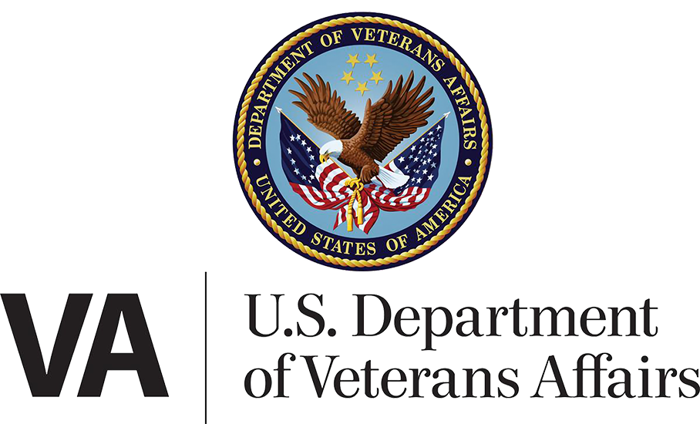

OCTO

**Language Assistance and Resources**

**Product Guide**

Version 1.0

June 2021

**Table of Contents**

Product Overview…………………………………………………………………………….……………………….2

User Access………..…………………………………………………………………………….……………………….2

Navigation and Functionality………………………………………………………….……………….……….2

**Product Overview**

Our Limited English Proficiency (LEP) Veterans and their family members/caretakers need to know how to get language assistance, file discrimination complaints and apply for benefits. This information needs to be provided in their native language.

By adding navigation to the VA homepage footer we will provide highly visible, quick access to 3 newly created landing pages (Spanish, Tagalog and Other languages). These pages will provide important info to users as well as link to some of the existing translated content across VA.gov.

**User Access**

Users do not need to be signed in to VA.gov to use this feature. The feature will be available for any user who visits the VA.gov homepage (or any page containing the footer element).

**Navigation and Functionality**

Footer: [VA.gov](https://www.va.gov/)

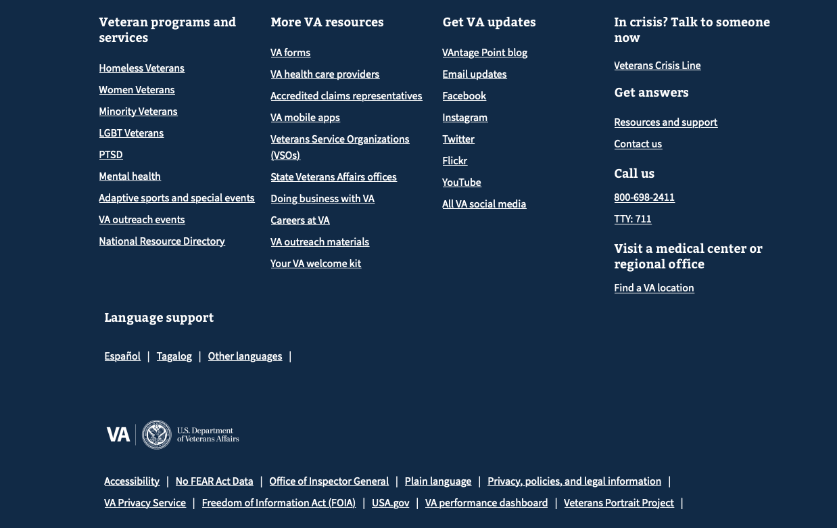

!Please Note!

* There’s been a delay in receiving the translated content for the Spanish and Tagalog pages; the screenshots below show placeholder content and will change before we go live.
* We are working with our partners in VA on the content for these pages and will be adding and removing resource links as needed. Please be aware that this page will continue to change and evolve.

**Spanish page:**

<http://www.va.gov/asistencia-y-recursos-en-espanol>

**D R A F T**

Figure 1: Spanish Language Assistance and Resources page

**Tagalog page:**

<https://www.va.gov/tagalog-wika-mapagkukunan-at-tulong>

**D R A F T**

Figure 2: Tagalog Language Assistance and Resources page

**Other languages:**

<https://www.va.gov/resources/how-to-get-free-language-assistance-from-va/>

Figure 3: Other languages, Language Assistance and Resources page